NATIONAL BROKERS LIMITED
http://nationalbrokersbd.com/
Tea Auctioneers since 1948
TEA MARKET REPORT – Sale 01 held on Monday 29th April, 2024

CTC LEAF : 23,685 packages of tea on offer met with a strong but selective demand.
BROKENS: Best Brokens were very strongly competed for and mostly sold above valuations. Below best met with a good demand and sold in line with quality with some withdrawals. Lesser quality met with much lower bids than valuations and met with heavy withdrawals particularly the plainer varieties. BLF teas were mostly neglected as bids were much lower than price ideas.
FANNINGS: Best Fannings met with a strong demand and were often dearer following quality. Below Best/Good varieties met with a fairly good demand but buyers were somewhat selective in their purchase. As a result, quite a few teas were withdrawn having failed to meet the valuations. Medium teas met with a limited demand and few teas sold at valuations. The bulk of it was withdrawn. Plain varieties met with a very discriminating market and were mostly withdrawn owing to low bids. BLF teas were mostly neglected as bids were much lower than price ideas.
DUST: 4,840 packages of tea on offer met with a good demand. Good liquoring Ds and CDs met with good competition and generally sold above Brokers’ valuation fetching between Tk.419/- and Tk.295/-. PDs and RDs were well supported and rates for these ranged between Tk. 245/-and Tk.280/-. BLF Dusts proved difficult of sale. Loose tea buyers lent good support whilst Blenders were selective in their purchase.
COMMENTS: This was the First sale of the season which met with a very strong demand from the Loose tea buyers for black, well made teas backed by strong useful liquors. Other varieties met with a discriminating market and only a fair weight was sold with large withdrawals. Blenders were very selective.
Good liquoring Dusts particularly CDs were a strong feature of the sale.
Our Catalogue: (Sale 1) Avg : Tk 287.12 , Sold 50.35 %

Quotations – This Week – (In Taka)
Brokens | This Week | Fannings | This week | Dust | This week
Best | 300-350 | Best | 280-330 | PD | 270-276
Good | 250-280 | Good | 250-270 | RD | 245-419
Medium | 235-245 | Medium | 230-240 | D | 245-414
Plain | 190-210 nom | Plain | 190-210 nom | CD | 245-410
BLF | 150-160 nom | BLF | 150-160 nom | BLF | Unsold
Exchange Rates 29th April 2024 Sterling Pound 136.9077 Dollar: Tk. 109.5000
Top Prices – This Week
Category – CTC | Garden | Grade |  | Package | Price | Buyer(s)
Brokens | * Luskerpore |  | GBOP | 10 | 403/- | Nishat
Fannings | Ghazipore |  | OF | 10 | 350/- | GT
Clonal Brokens | * Madhupur |  | GBOP(BT1) | 10 | 850/- | Mollah
Clonal Fannings | Ruthna |  | GOF | 10 | 415/- | Nijhum
RD/PD (incl.Clone) | * Madhupur |  | RD(BT1) | 10 | 419/- | Danish
D (incl.Clone) | * Madhupur |  | D | 10 | 414/- | Lovely
CD (incl.Clone) | * Luskerpore |  | CD | 10 | 410/- | Shawon
Orthodox | * Kazi & Kazi |  | OP | 5 | 850/- | GT
* Above price(s) realised in our catalogue
Offerings
This Sale (Sale 1) Next Sale (Sale 2) Season 2024-25 Season 2023-24 Season 2024-25 Season 2023-24
Type | Packages | Qty/Kg | Packages | Qty/Kg | Packages | Qty/Kg | Packages | Qty/Kg
Leaf | 23,685 | 1,181,881.5 | 13,640 | 680,636 | 16,998 | 848,200.2 | 21,109 | 1,053,339
Dust | 4,840 | 241,516.0 | 2,987 | 149,051 | 4,376 | 218,362.4 | 5,082 | 253,592
Total | 28,525 | 1,423,397.5 | 16,627 | 829,687 | 21,374 | 1,066,562.6 | 26,191 | 1,306,931

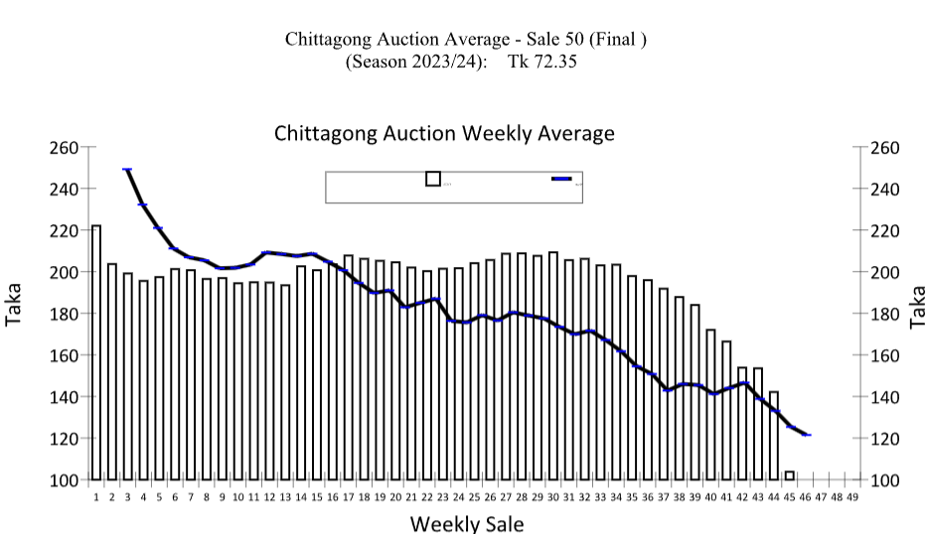
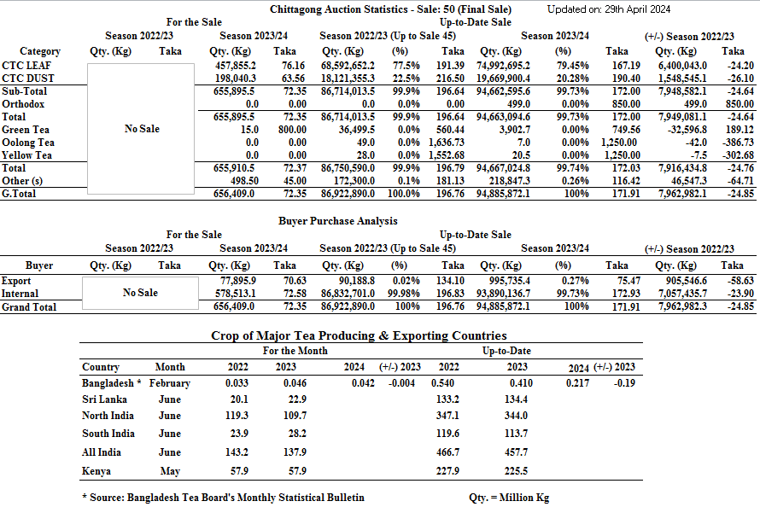

OTHER MARKETS
.
COONOOR SALE 17- 27TH APRIL, 2024
DEMAND: - Selective demand on the range of teas on offer. MARKET: -The total CTC leaf teas sold this week was 70.48% (754770.93kgs) of the total offering of 1070832.96Kgs. Major Blenders were fairly active. Exporters and some Internal buyers operated on the medium and plainer teas with major blenders being very selective especially on blacker Fanning. Browner teas were discounted. The Major Blenders absorption was at 42.27% of the total CTC leaf sold.
CTC  Leaf(USC/KG) | Best | Good | Better Medium | Medium | Plain
Larger Brokens | 168-198 | 128-141 | 113-115 | 101-113 | NQTA
Medium Brokens | 181-242 | 120-151 | 114-119 | 108-113 | 107-108
Smaller Brokens | 205-265 | 120-151 | 114-119 | 106-113 | 102-104
Fannings | NQTA | 150-161 | 116-137 | 108-115 | 102-107

MOMBASA SALE 17 – 22nd & 23RD APRIL 2024
Fair general demand for the 253,280 packages (16,928,042.00 kilos) available in the market with 41.57% neglected.
CTC QUOTATIONS | BP1 – USC | PF1 – USC | PD – USC | D1 – USC
Best | 255 – 290 | 300 – 412 | 300 – 454 | 304 – 345
Good | 255 – 290 | 280 – 332 | 290 – 315 | 288 – 321
Good Medium | 255 – 265 | 262 – 326 | 280 – 315 | 280 – 323
Medium (KTDA) | 250 – 252 | 244 – 302 | 258 – 285 | 245 – 267
Medium (Plantations) | 130 – 164 | 116 – 216 | 106 – 202 | 126 – 236
Lower Medium | 100 – 172 | 100 – 154 | 110 – 176 | 107 – 179
Plainer | 052 – 111 | 045 – 115 | 070 – 134 | 058 – 134

